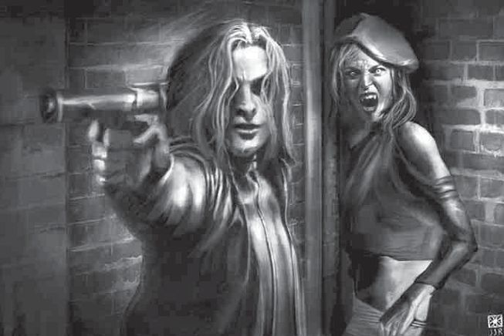
Bullets vs Bloodsuckers
Special Price List

Chips $3.00
Water $0.50
Sarsaparilla $1.20
Standard Adventurer’s Kit: $4.00
- 1 packet of Chips,
- 2 Cans o’ Cool Drink

These Special Prices are Valid ONLY for the BvB event.
For queries please speak to Frames
It is the funding from our memberships that allow us to purchase these books, and to run events such as this.
If you would like to become a member of the club, or if you haven’t payed your membership fee’s this year. Please, during an intermission speak to Leonard, Frames or Roland.

