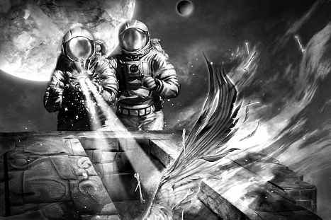
Standard Equipment List
Water: 60sp
Soft Drink Cans: 80sp
Splits/icy-pole: 1.00gp
Drumsticks/Cornetos 2.00gp

Chips: 3.20gp
Rainbow Popcorn 2.20gp
Dip 2.50gp
Pies 2.0 0gp
Pizza Pockets 2.20gp Bagged Chocolate s 3.00gp

