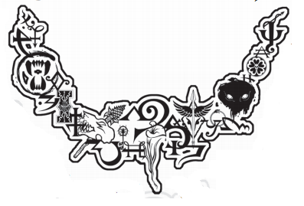
Furries vs Fairies
Special Price List

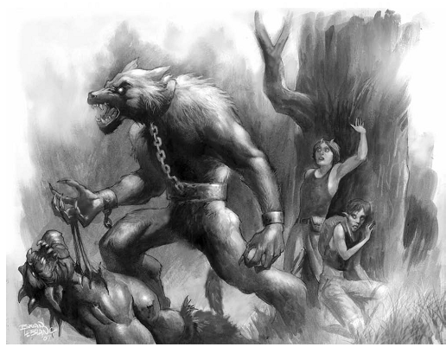
Can o’ soft drink: $0.80
Chips $3.00
Water $0.50
Sarsaparilla $1.20
Pies $2.00
Salsa Dip $2.50
Standard Adventurer’s Kit: $4.00
- 1 packet of Chips
- 2 Cans o’ Cool Drink
Yes, I am aware that some things are still at normal prices.
And Yes, I know sugar free creaming soda defeats the purpose of creaming soda.
These Special Prices are Valid ONLY for the FvF event.
For queries please speak to Frames

