Club Name: Unigames, UCC, Unisfa and Science Union
Name and position of nominator: Rowan Ashwin (Vice President of Unigames)
Phone number: 0451 141 269
Email: heilar@live.com
WHAT IS THE BEST INCLUSIVE EVENT AWARD?
Each year, the Societies Council (SOC) provides an award for the best inclusive event run by a SOC affiliated club. This is to encourage clubs to ensure their events are diverse in the students they attract, cater to a wide variety of interests, and provide an inclusive atmosphere. The Best Inclusive Event Award is presented at the Guild’s Annual Cruickshank-Routley Memorial Ball, with the awards being $500 for 1st place, $300 for 2nd place and $200 for 3rd place.
BEST INCLUSIVE EVENT CRITERIA
The winner of the Best Inclusive Event Award is determined by the SOC Committee. Please provide the following information in your application:
- Briefly outline event for which this application is being submitted; include details such as when, where, price, attendance and a brief description of the event
- Provide photographic evidence of the event
- Provide a copy of any advertising used to promote the event (G-News submissions, posters, photos of any banners etc), if this is unavailable a description will suffice
- Provide proof that the event was submitted to the Guild (either through the Events Calendar or an Event Management Plan)
- Briefly outline how the event meets the definition of “inclusive”
- Any additional information that may benefit your submission.

HOW TO APPLY
To apply for the Best Inclusive Event Award, clubs must submit a written application addressing the criteria listed above by the closing date as specified by the SOC President. Applications should comply with the following:
- Include a completed Best Inclusive Event Application Coversheet
- 10 page maximum, excluding coversheet
- Be submitted via email in PDF format to soc@guild.uwa.edu.au
- If hard copy submission is required, please contact the SOC President

For any queries relating to the Best New Club Award, please contact the SOC President at soc@guild.uwa.edu.au. We encourage your club to put a table together for the Cruickshank-Routley Memorial Ball so that you can be there in person to receive your award if successful, as well as join in on all the fun and celebration!
Charity Vigil:
The Cameron Hall Charity Vigil is an event run every year to raise money for youth focused charities within WA. Clubs within Cameron Hall get together to host a variety of events including board games, computer LANs and movie screenings as well as competitions with all proceeds going to charity.
This year Charity Vigil was run as an Inclusive Event, located in various clubrooms and the Cameron Hall loft on Friday September 20th, from 6pm till midday the next day. The 101 Participants were allowed to enter upon donation (minimum $10) and became eligible for various prizes including random door prizes, raffles and prizes for the largest donations.
The only complaint that people had about charity vigil was its effectiveness when it came to raising money, and several members caught up in our events and activities donated over $100 for the cause.
Whilst the organising committee consisting of several members from each club organised the bulk of the event, many members also stepped up to help clean, or run events throughout the night, ensuring its success.
There was a strict No Alcohol policy on the night which was advertised consistently and effectively on the facebook page, which was nicely juxtaposed with emas’ Ibiza festival happening downstairs. Several students found themselves between the two events, especially those in need of sobering up! The event was also Inclusive in the sense that people could come and go as they wished on the night, and there was no pressure to remain in the hall for the entire night.
Parkerville has just recently received the money, and are currently writing a formal thankyou letter to all parties involved (including the guild) which we cannot currently attach.
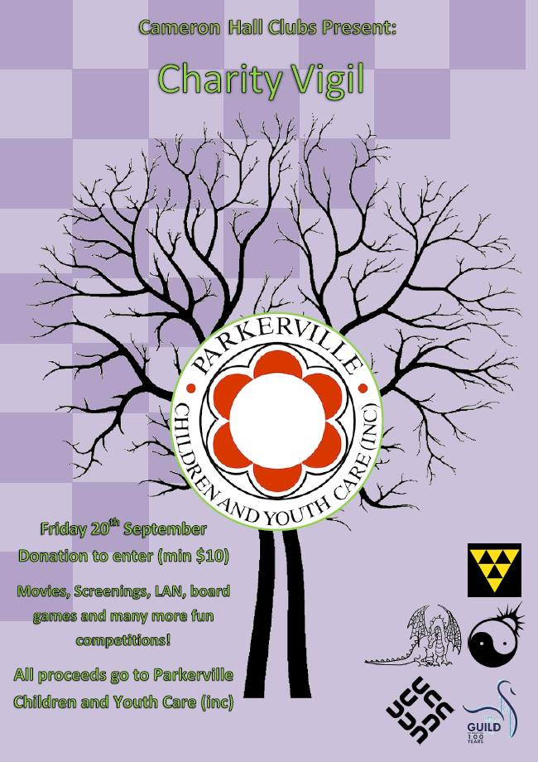
Main Poster
(Sponsor Letter)
Dear Potential Sponsor,
The Cameron Hall Charity Vigil is a long running charity event, run by clubs at UWA.
It is dedicated to raising money for local charities that help the young people in our state.
This year we are supporting the Parkerville Children and Youth Care Charity.
Parkerville Children and Youth Care is a Western Australian Not for Profit organisation that has provided care and treatment for children and young people for over 110 years. These children and young people are aged 0 – 20 years and have all experienced trauma from abuse. One of our mission goals is to alert the community to this extraordinary social issue that affects 1 in 4 Australian girls and 1 in 6 Australian boys.
The funds we raise will go towards the ongoing maintenance of child advocacy centres as well as the Armadale support network. To find out more about Parkerville’s ongoing projects, either go to their website at www.parkerville.org.au or feel free to contact me using the phone # provided.
The Cameron Hall Charity Vigil is traditionally attended by up to 200 of our members.
It is a night of LANs, board-games, and movies. Attendees collect money before the event. This money is collected up at the event, then added to what we can raise on the night, though raffles and the sale of soft-drinks and food. This year it is being held on the night of Friday 20/9, through to the next morning.





Each year we aim to make this a more successful event, and this year alongside getting more clubs involved, we are aiming for a much larger attendance, making it a great advertisement opportunity!
This year the Cameron Hall Charity Vigil has set a goal to raise over $2000. Towards this end we are seeking sponsorship in the form of:
- Food, or discounts to food: to allow us to cover dinner and breakfast at the event.
- Prizes, allowing use to run silent auctions, raffles and door prizes.
- Direct monetary sponsorship: tax deductable; cash, cheque or EFT accepted.

As a sponsor of the event you would benefit by:
- Having your name and logo on our posters around UWA
- Having your name and logo on the forms our members take around to collect donations.
- Having your promotional material presented and distributed on the night.

If you have any questions, about the Charity Vigil, or about Parkerville,
please do not hesitate to contact me.
Thank you
Rowan Ashwin
Cameron Hall Charity Vigil Chair 2013
Ph: 0451 141 269
Charity Vigil Donations Form
The Cameron Hall Charity Vigil is a long running charity event, run by clubs at UWA. It is dedicated to raising money for local charities that help the young people in our state. This year we are supporting the Parkerville Children and Youth Care Charity:
Parkerville Children and Youth Care is a Western Australian Not for Profit organization that has provided care and treatment for children and young people for over 110 years. These children and young people are aged 0 – 20 years and have all experienced trauma from abuse. One of our mission goals is to alert the community to this extraordinary social issue that affects 1 in 4 Australian girls and 1 in 6 Australian boys. For more information visit .
The funds we raise will go towards the ongoing maintenance of child advocacy centres as well as the Armadale support network
Entry is by collection of donation. Minimum collection for entry is $10, however for us to reach our goal of $2000, we need every attendee to collect at least $20. Attendee's who meet this goal will go into a raffle for additional prizes. Our best collector will receive an even more amazing prize.
Door Open at 6:00pm Friday 20/9, and the event ends Saturday 21/9 (last weekend of study break). There will be a pizza run organized around 8pm, though it is, of course, completely possible for attendee's to leave to organize their own food (or pizza run for that matter) at other times.
Donations can be made online. Please arrange a bank transfer to:
"The University Computer Club", BSB: 036054, ACC 285739,
placing in the description the words: "Charity Vigil", and the name of the collector and donor.
Donations are technically tax deductable, and if someone requires a receipt for such, please direct them to me and I can have one written up.
If you have any questions, about the Charity Vigil, or about the Leeuwin,
please do not hesitate to contact me.
Thank you
Rowan Ashwin
Cameron Hall Charity Vigil Chair
Ph: 0451 141 269
Charity Vigil Donations Form
Donor Name (optional) | Payment Form | Amount
 | Cash / Cheque / EFT | $
 | Cash / Cheque / EFT | $
 | Cash / Cheque / EFT | $
 | Cash / Cheque / EFT | $
 | Cash / Cheque / EFT | $
 | Cash / Cheque / EFT | $
 | Cash / Cheque / EFT | $
 | Cash / Cheque / EFT | $
 | Cash / Cheque / EFT | $
 | Cash / Cheque / EFT | $
 | Cash / Cheque / EFT | $
 | Cash / Cheque / EFT | $
 | Total: | $

Thank you for your kind donations.
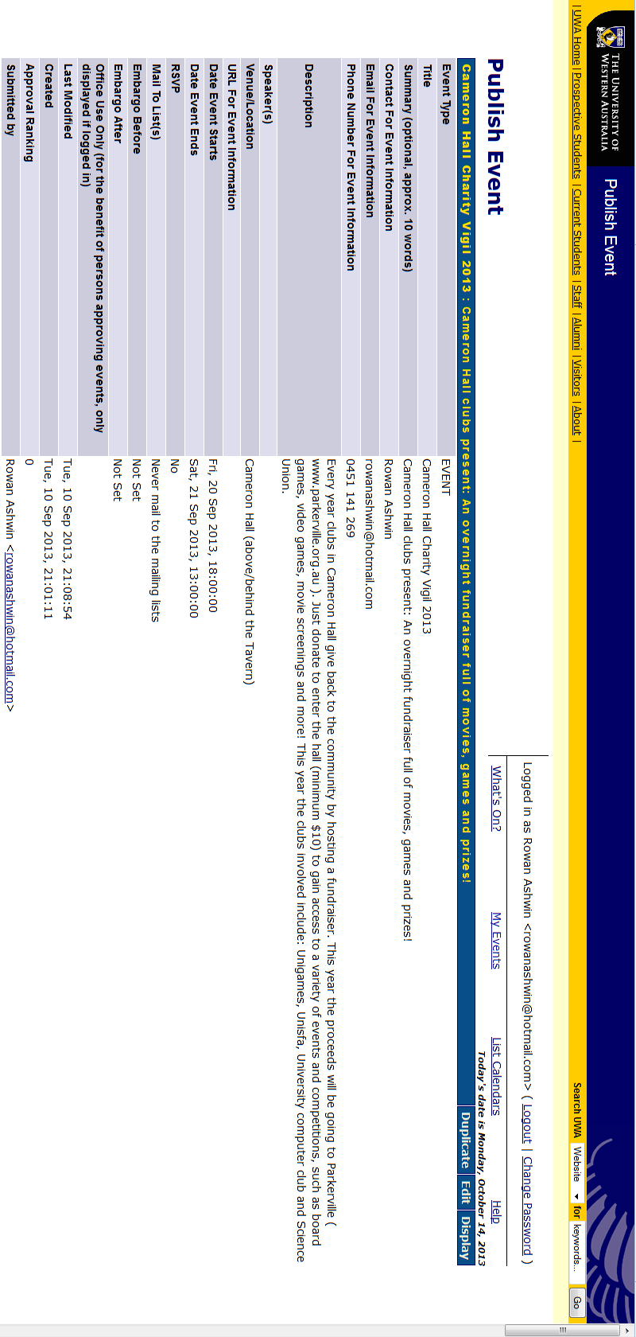
UCC Lan:
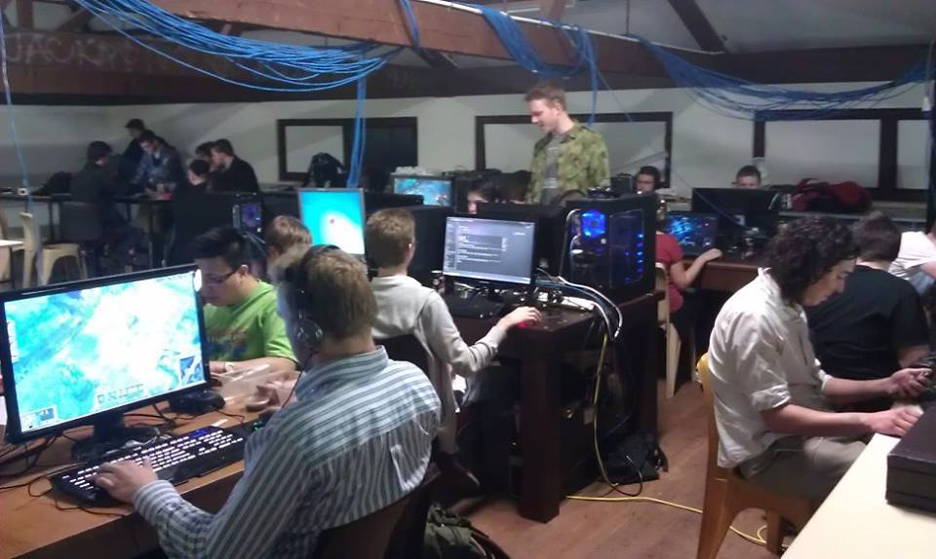
Un

Unisfa Movie Screenings/N64:


