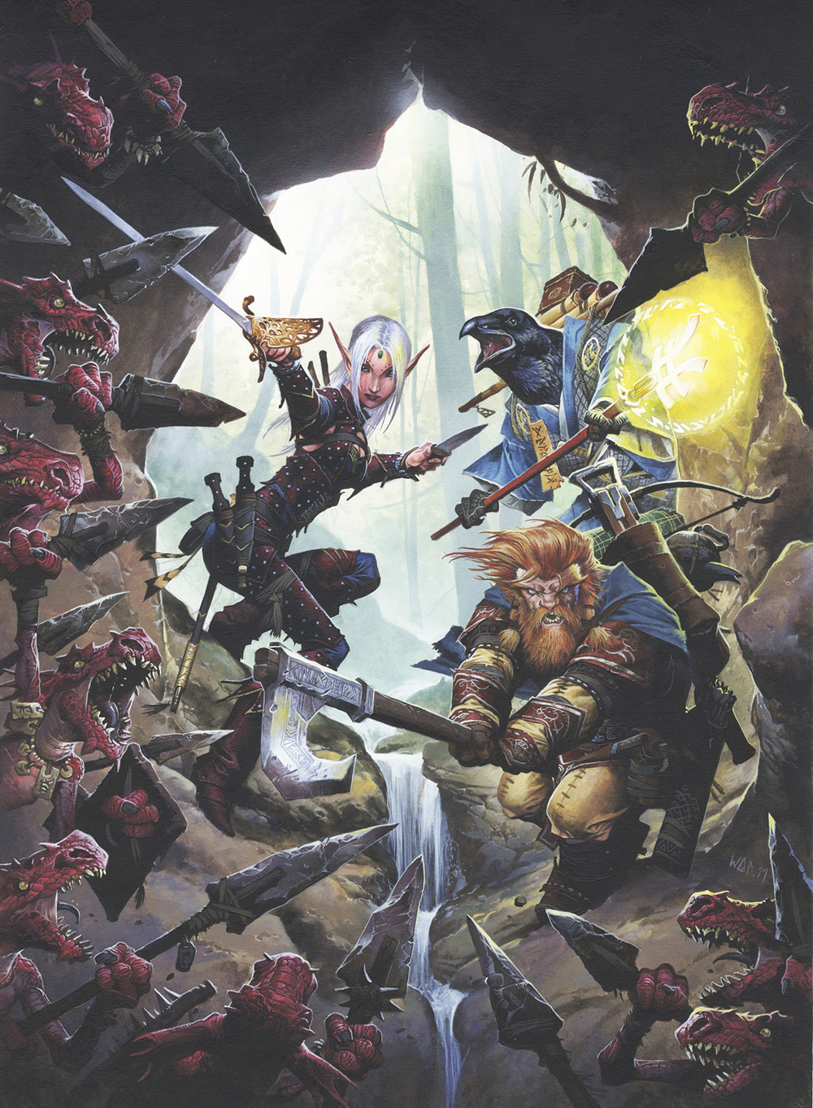

Come up to the Cameron Hall loft for a great night of roleplaying,   
with the Perth Pathfinder Society,  
hosted by Unigames

When: Friday 30th and Wednesday the 4th

6:00pm till late (like 11).

Meet some new people from the Pathfinder society of Perth!  
for more information

Make sure to register at **warhorn.net/perthfinder** more information available at this site and on the facebook event page.

COMPLETELY FREE!!!