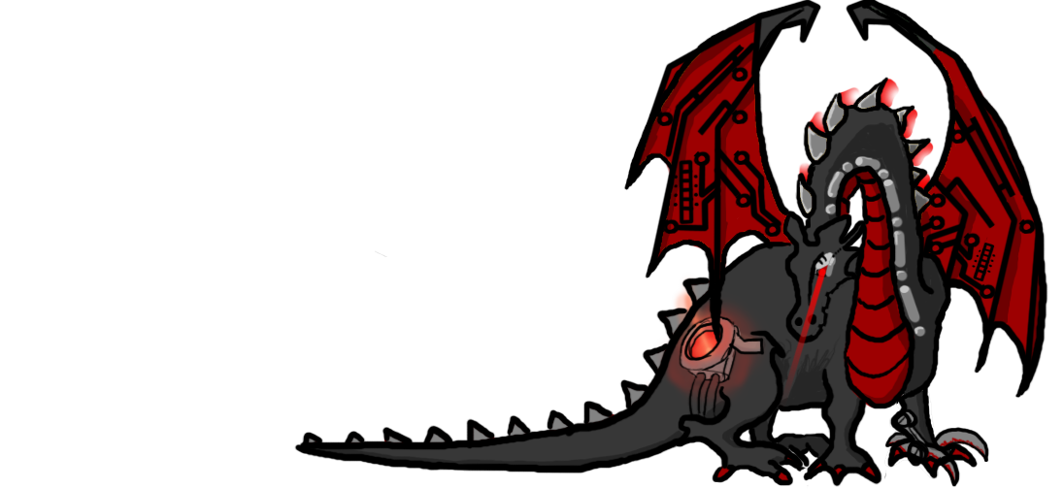
UNIGAMES MEMBERSHIP

Name:______________________________
UWA Guild Member?
Student Number (If UWA): _____________
Email Address: _______________________
(Leave this field blank to use your UWA email address)
Phone number: _______________________
Address: _____________________________
_____________________________________
Interests (Tick those that apply):
RPGs Wargames (40k etc.) (D&D, nWoD, DH etc.)
Board games Collectable Card Games
Air Con Snacks and Drinks

UNIGAMES MEMBERSHIP

Name:______________________________
UWA Guild Member?
Student Number (If UWA): _____________
Email Address: _______________________
(Leave this field blank to use your UWA email address)
Phone number: _______________________
Address: _____________________________
_____________________________________
Interests (Tick those that apply):
RPGs Wargames (40k etc.) (D&D, nWoD, DH etc.)
Board games Collectable Card Games
Air Con Snacks and Drinks

