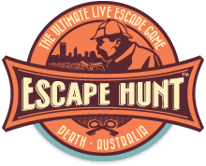
UniGames Escape Hunt
Thursday 1 October (study week)
5:00 – 9:30PM

Name
___________________________________________________
Student Number
___________________________________________________
Contact Number
___________________________________________________
Emergency Contact
___________________________________________________
Emergency Contact Number
___________________________________________________
By signing this form and waiver I exempt and release the University of Western Australia, the UniGames society, the UWA Guild of Undergraduates, and all their representatives from any liability or responsibility for personal injury, property damage, and wrongful death associated with the activities of these organisations on 27/05/15.

Sign _______________________________________________________
Gatekeeper (Sign when attendee has paid $25)
___________________________________________________
UniGames Escape Hunt
Thursday 1 October (study week)
5:00 – 9:30PM

Name
___________________________________________________
Student Number
___________________________________________________
Contact Number
___________________________________________________
Emergency Contact
___________________________________________________
Emergency Contact Number
___________________________________________________
By signing this form and waiver I exempt and release the University of Western Australia, the UniGames society, the UWA Guild of Undergraduates, and all their representatives from any liability or responsibility for personal injury, property damage, and wrongful death associated with the activities of these organisations on 27/05/15.

Sign _______________________________________________________
Gatekeeper (Sign when attendee has paid $25)
___________________________________________________

