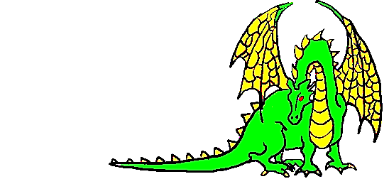
Unigames Membership
2017
Name: _______________________________
(Print Clearly)
□ UWA Guild Member
□ Unigames Fresher (First time member)
Student Number (If UWA): ___________________________
Email: ___________________________________________
(Leave blank if you want us to use your student email)
Phone Number: _________________________
Address: _________________________________________
_________________________________________________
(This will be used to hunt you down if you don't return our books/games)
Interests (tick all that apply):
□ Roleplaying games  (D&D, nWoD, DH etc) | □ Wargames  (WH40K etc)
□ Boardgames  (Monopoly, Risk, X-COM)  □ Reasonably-priced snacks | □ Collectable card Games  (MTG etc)  □ Air-con
□ Interested in joining a fresher campaign
Sign: ___________________ Date: _________________
□ $5 Membership Fee Paid □ $7 Non-Guild Fee Paid
Gatekeeper: _________________________________

